Is math powerful enough to keep vampires away? Find out as you explore the question above through the use of a spreadsheet. What you discover may be shocking!

What do you know about Vampires?

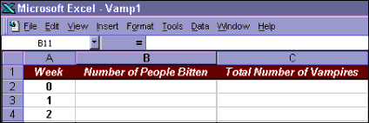Step A
Open Excel and set up a spreadsheet using heading like in the example shown.
Hint: Double-click on the top of the vertical line between columns to fit column widths to your headings.

Type your name in cell D1 Step B
Begin entering the data into the spreadsheet. On week zero, there is one vampire but no people
are bitten. On the first week, one person is bitten and that means there are now 2 vampires. On week two, each of those two vampires bites one person and that means there are now a total of 4 vampires. Now that you get the idea, carry that through to the end of Week 8. How many blood- suckers do you end up with?

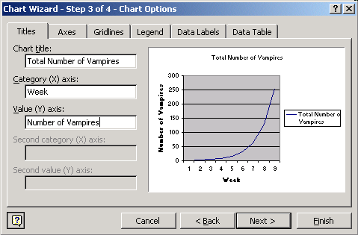Step C
- Select your data in Col- umn C, go to Insert, and choose Chart. Using Chart Wizard, select a type of chart that shows data over time. The chart below is one example. Click next.
- You will see an example of what your graph will look like. Click next.
- On the next screen, type in the X and Y axis labels as shown. Then click Fin- ish.
- You will now see the graph in your spreadsheet and by clicking and drag-
ging it, you can move it below the data where you can see both the graph and the data you have entered.

- What kind of trend does your chart show?

- Print out your data sheet and your chart to have on hand for the next step.

Step D
Now you’re going to get the spreadsheet to count seven more months worth of vampires for you—in mere minutes!
  - Look again at your statistics through week 8. In math terms, what is the rela- tionship between vampires at the end of the week and the number of people bitten the next?

  - Here’s another way of looking at it: What pattern do you see from week to week in the number of people bitten? What about the week-to-week vampire numbers?

  - Now drag your graph over to the right so that you can continue your data down the left side.
  - Create a formula for columns B and C in Week 9 (that’s cell B11 and C11, respectively) that will extend the pattern of Weeks 0-8. Hint: Remember to begin the formula with = and that * is the sign for multiplication.
  - Hit Enter when you are finished typing the formula, and check to be sure that the pattern con- tinues.
  - Now you can use Excel’s autofill feature to complete your worksheet. For column A you can highlight the cells A9 and A10, point to the “handle” in the lower right corner of A10, and drag it through A37.
  - Now fill in column B by using autofill to drag the formula through week 35 (cell B37). Fill col- umn C by dragging the formula in C10 down through C37.
  - Format your vampire stats by selecting columns B and C, going to Format, choos- ing Cells, and selecting Numbers on the list. Type in 0 decimal places, and select Use 1000 Separator.
  - Save your work.
  - How many vamps are there at the end of Week 35? If your formulas are correct, you should show 34,359,738,368. Say that number out loud: 34 billion, 359 mil- lion, 738 thousand, 368. That’s a lot of living dead!

Step E
So how does your vampire census match up against the actual work poplulation? Here’s how to find out.
- 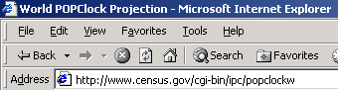Launch Internet Explorer, and go to http:// www.census.gov/cgi-bin/ipc/popclockw, the U.
S. Census Bureau’s World POPClock. This gives an up-to-the-second projected count of
the world’s human population, based on actual numbers plus estimated births and deaths.
- What number is showing in bold type?
- Highlight this number and copy it.
- Go back into your spreadsheet and paste it into cell C38.
- In cell D38, type in the label People on Earth.
- Check your sheet in Print Preview to see if the graph is going to print on the same page as the data. If necessary, move the graph or resize it.
- Save and print your sheet.
- According to your mathematical model, how many of the world’s people are actually vam- pires?
- At which point in your chart did the entire population of Earth become vampirized?

- Could this possibly be true? what mathematicians call a “proof by contradiction.”
- Staple these sheets to your spreadsheet and give to your teacher.
Congrats! You have just constructed

